Logo final project and color plate

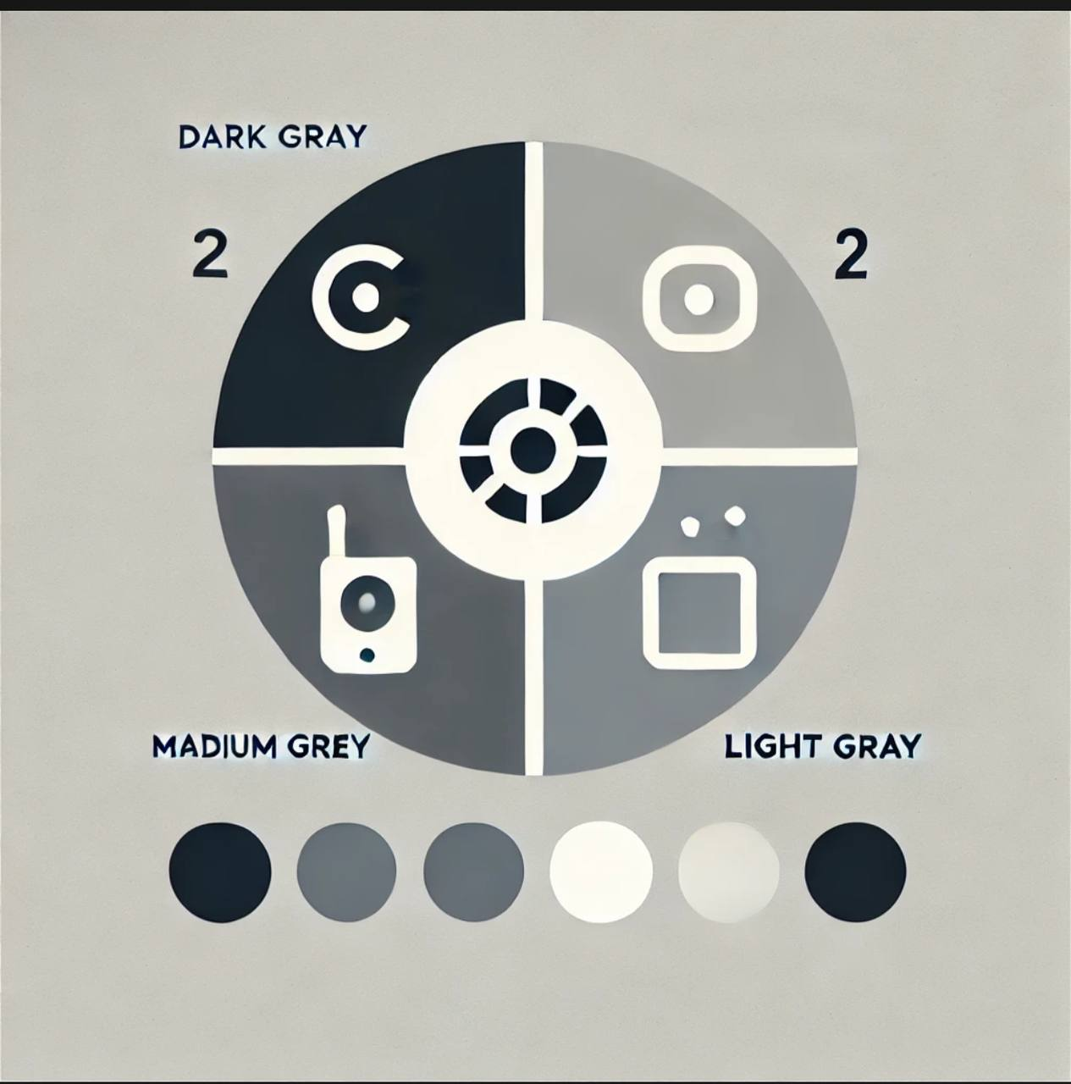

Based on the uploaded logo image, here's an analysis of its **color palette** and what it represents:

### Color Palette:

From the logo, the primary colors used include:

1. **Light gray** for the background.

2. **Dark gray or black** for the main elements (text and outlines).

3. **White** for the inner space to emphasize the letters and symbols.

These colors combine to create a sleek and minimalistic design, giving the logo a modern and professional look.

### Symbolism:

The logo prominently features the letters **SBP**, which likely stands for "Smart Switch Button Pusher." The circular design with clean lines suggests that the product is a **smart device** designed to **automate button pressing**. The use of simple, bold typography emphasizes functionality and innovation, aligning with the concept of a tech-driven solution.

